ciffiR&q-,
<t(ql[F.t
^{/aa64r; if-;,} frDlv
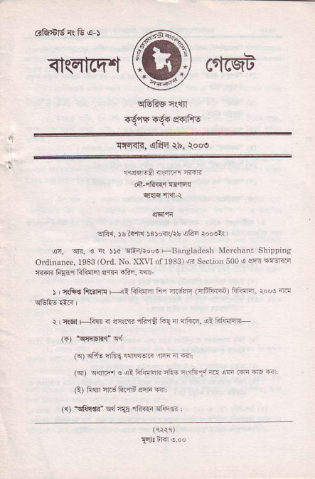
_{{tti{R,} ^{qfPm} _{tb,} )ooe
1'Ff4Es ntflFr ffi
d lnF{rrd$q:r
qI{6'mL\
-rtii. N a<'r'1 slavrx !c! io'llr
^{q.} w. € ^{ir} _{))d} ^{qEr/roo!} +Bangl^desh llercbsti Shippn,g Ordnrance, r9$ lord. No. XXVI of 19331 !i_{So.rio. 500} i sft l:ffi :ffi 6{{. CRIB s.rF iin. iq3-
r ' c&€ ftfffi H1 lifffi ta rr;rF _{I'iFf+irr- )} E@F. r"'! m
r r(5 r @. ^{nqr} _{sq? tn} ^{r} ff. ! ?iff
(F) _{!|fiEnc"} qd
_{{9} ^{qltu} nfi! llrrlElF nfl 4 €,
_{(q)} ^{qsE1} ! ^{qt} _{Ffqrrit} ^{,Eii} nlrEd a.r 4- Fr{ 1F -,
(!) Fq r.;fi.a6 ffi €r:
(1) {qqtr" _{ad rE rii{5} ^{qtnli} ,
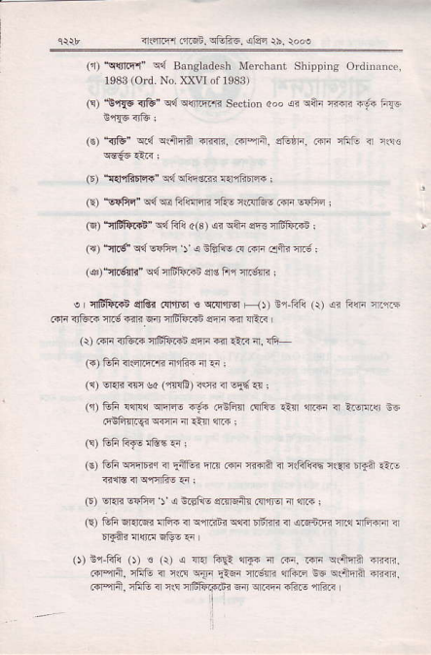
e*r _{4ffi rr6t. TGtu6.} ^{(|!4} $. rod
^{(5r)} \brqr" cd Ba.sladesh Merchoni Shipping OInodncc, ₁₉₃₃ ^{(Ord.} No. XXLI of rcas)
(!) $,rqE _{l&"} ^{qd qrmrra} Soction aoo _{a3} ^{qAi} ffi -yi ft{c (€) _{"il&"} q{ qdn? ^{q.<r?,} .aqn. ecr|d. 6ri initu a 's€
(r) _{tfl fi tl4{"} ^{q{} cliieii €1fiarft ;
(E) _{"e{frc"} ^{qd} w FAfcE nQs r{qtu! .iri ^{!c1ir} i
(E) "iffi}!" _{wftli c(3) 4?} ^{qfti} sR 4tur:
_{G')} ^{tnrs} _{WwFi 5} ^{q} nfiiE n .sri .xfti {d i
_{(4)"1l6li"} ^{q{ qffi.4i qs} I'r {6!8 :
o isfrran d8_d .{nlgl _{s} ^{q!ql$6r F} _{1,} ^{sq-Fli} _{1r)} ^{,e?} _{Ffi} q(rr- _{.fir <,tu - {.S {iR} ^{qn} n1ffii.t e'1r @ {EF r
^{(r)} .4]i irGF a6trr4n eq]i €l .:ir ir, Ifi-
(6)ffiasnl'liaftia.rl
_{{{)} Er$r@ k (.n!E) is 4 -16 ^{q{} i
(r) CF @q wrrc iF nnF{l .tF6 ^{€n} _{".r.F} ir irw$ ;6 _{cnFTt-g< wF} ^{:'r} -i{ m ;
(!) GF FfE nE€ .r ;
(6) _{Cfi} ^{qnEEq ?r} _{EAF?} fi@ riri aff? ir rrSk€ nr1rr fan €i 411ts4qrrlhEea:
_{F) oRR} ^{q'!Fi} _{x} ^{q} &EirE Elnrqtu.{rjrrq { ffi I
€) _{&F 6r1t@ Illii 4} ^{q1rBi? qrir} _{rdriri it aFn E {.i iFfirir} q 'r{"j {@ 6&E 3 |
_{O)} ^{n1F1i} _{O)} ! {{ ^{a ?ra} _{fu:} ^{!flF} ir irin. r{i clanA 6|m. _{ioreti, mF n rw} ^{q{n} !&n rl.;m 1lf€i ₊₆ ^{q{tuj} aF<F. ^{(qr-fia.} cfre a rls aEtFq{6? 6{ ffi il?F diF
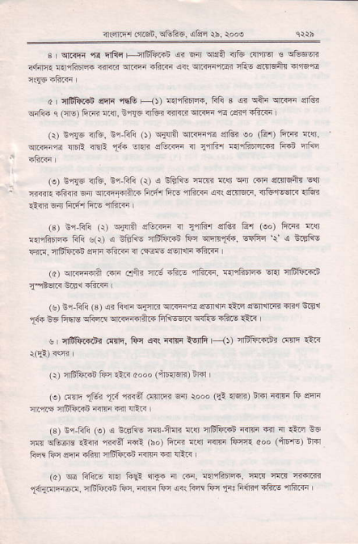
n(nrr _{d.qi Eiift',} ^{qrd} {b. roN
_{s} ^{q.rF{,f{} nfir FjlBla?i <? @ sr{A {jfu .!lll]q _{s} qtuw rfiln{ €,lfiIr:.4 _{nr<R} ^{qr'ffi} .|*rn ,4?! q.rEiiEr ^{qtu} {tr6tu orqii
_{a I dfrtud} ^{qFE} iqB ^{F} _{{t} {nqR5]a6, Fli s @ qS" ^{qm} $ls. ^{qift.} c (fl9 fiz{{ !i{], s!{c {tui _{<rRir craF} ^{'6} t'ri{ iftF I
(r) sr{F <'&. ^{Br-Fl!} _{o)} ^{q{qil qr'mir,o q'&{ so} _{G1} ^{Fim 4{r q.@,rd !l'R rrcE} _{{i{} ^{qni} ee.iri n _{11Ar} ^{q41fr'rl@} FRn iilq
, (o) srTs 3]16. ^{E1-Rll} _{Q) < iGfrE lnin? wct} ^{qdr.oi} _{ar} ^{qih} E1r ' {crrEdiiri6er.rrt{n'Fi@tifiF,rftri ^{(r(e!!&r,irturffi} {Gi _{Arr?} ^{qn} fiR{r firq {fi1F I
(r) Er-Fl! _{(r)} ^{qflA} a&rli ^{il} _{t"iii.l} crtu4 Ar (oo) fte {$ {.lqfrn4i Ffl s(r) s ifrli! ifitfti4i _{fir} qlnnt4r, _{qqfrr} ^{'r'} a trflE _{f{ !, rlffii.i} ^{qnr} ?ftnr { cFEF el€ r.lln rfizd I
_{(a)} ^{qiEefi} Rrr (Jiir _{3ri6 41?F} ^{'nF.F,} {{lrF R Rrq a6ii.Flt _{rBEf.r} ^{niE1} _{"ftqr} I
($) ir-Fli (3) _{4 frcli} ^{qjrlEr q.rlr'} e 46irri €rc evnni? mq $81 _{X+$} BE _{Fhrd} ^{qftff qnliilft"} _{FIi@n<} ^{q<Fo} r'ftE 1l1<
^{u} 4ffi FF, tn .tr.i arq' Frfi _{1r'} flft.dni !f@ 'F
(\) 4$ft..n ftr 1!rr oooo (4556R) Bm L
(e) ^{.ffq} _{f6 t':{,rn€l} .r'ntqi Fi, _{rooo} (rl:mq fiar inqi tu aiF ^{qr.,114} cfrliriD {irs F<r lFir i
(3) E1-Fn (e) < €.E1i! r!{-nl]i _{{!r} ^{q$&id} 4{!i 6ir d ri.q sG w cFcrs _{ci:ii} 'ii<a:f4? (ho) iiR 4q 4{rr Frr{ doo (iFF5) iF licr Frr 4rli .frrl 4frftr!! iqF Fir {A1n
(o) R F&.E ^{{ra} _{fui} ^{qre} 4 !{i, r{'rfit1n. rni tlrll rr'I.n .t{qmq{€!. ^{qfiftii} tur, inli frn {it Fn l}r 1F3 h(r.i i6.s rhF
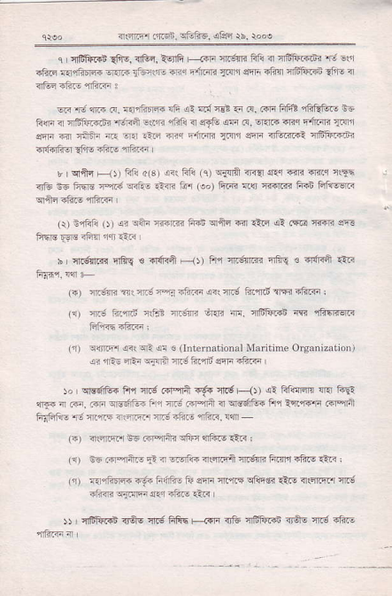
ar.@r .fiFd. 5i.to6. !'fd rb. rooo
_{I iBft.in{i€,} ^{qGr,lorfi} L .qi _{4.;fl. fti 4 46totdd?'F} ze nFF RrlElF @.i _{ri-iE} ^{-,1 Fiim} _{A:n'r} srrr _{itun} ^{:iii'Fi.{n} _{?i-E} <
@ d c c. TarirF lii ai n { rct 5 _{F, Fr ffi} ^{qfrEEre} E3, lim ^{1TfiF.FJ.} _{"F,ti} ^{-1in} _{"iii1. aTe} ^{qd} .?. ^{q?rr} _{mq} ^{qrm} T:r _{ffi n rnir-} nQ .r1 _{i-F m{} ^{Finnri} _{1flrl} ?@ 4'i4i-.1 a6fi.dti flidF3 _{{i!} ii?F {ttrF
r crftE Fr)) Er a(3r _{si: fif!} (q) ^{<iqi it} _{?r!r1ffi} @r rqE r]L -6 iire T-rn ^{rii-} €n tu (!") Fi€ alr ffi trii Fif€@
^{(r) t'rffi} _{t))} !? !A' _{Fm irii} ^{qrft} 6 ftq a? rm ffi aE
_{x} ^{qlFtuR} 'lli{ € _{"r6{fi} ' _{lJ)} A1{.;$@ tr6! ! ^{q@} iiii (i) _{F_e!r?} ni! _{r-} ^{pa} ntsF art {i3 tqnd rm iftF i
_{tat} r; t/dtd n$- _{n.tF} ^{q{i} @. n16tu.i"t * i€qffi l"'|-?a i,?s,
_{(1) irFrdm url 4 .} ^{(lniefDationol} Maitine O.sanizrlio.l !? ^{jrE-} 44:i riaPl 4r;1?.mi sF -ftF
_{i"} ^{q1!lir6i} Fr'1 cr.3 tr-in {.6€ _{n} ^{g} --.()) _{<: lifl1m} ^{qr?} @ ?rF4 ^{i} rnr. 6a e-35iin i 1 T.; rr-'ni r] lre6rEn tfl -a@F .flarir _{Fr-r6i{} ^{.,? ft1r} " ,ry xr3 aF{ai nfac. c4
(.) _{?!llJ@r iE FPnni} std ^{?.\ftF} !i.r :
(1) nE inaift. F 1-rqic a!4trii 4dF li.qr'r ift.o ani ,
(1) rrnFarn, i-!1 i;{'n- ii ff ft'rrn ^{q1i.q} €.E {rffir ir.; _{-,?n} ^{q1nq f.r} _{"tut} <'i
)) nffir.i irOE {6 fiFh <+ri 4& {itF'in irdE nri -ti'F
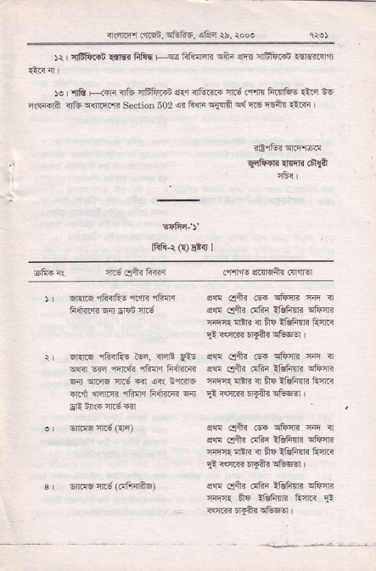
_{aqirr al.6t,8tuF5.} ^{qfs} $. roo!
)r iEfir'{t rtsr fiftq r _{s ftli{qE} ^{qfti} _{sF{} ^{qFFrr!} ?qrsntlrl
_{)o} ^{-iE} F-{rri nG 16ft.4n a.:r <rtu@ n 3.'r.m FErfr.5 €rq 36 ^{qlErd?} _{il&} ^{qinrq'.ra} _{section 502} ^{q?} _{F(ri qffi} ^{qd} Er€ E6+i rtR
IfiR-t ^{(!)} fi 1
q.Eq ^{?ltR'tu} _{ii.r{ cF{r} ^{qq} Oftr @ ^{qfiim} n { sd afl? _{.!hi iEfitrli} qftm
riq"{ E _{ri} ^{q} E? !EF1r' R{R
^{qFr.q} _{"ltRR!} ?sr, ^{rl!i!} liE ^{q{ir} @ ,lqr1! ^{qiinq} Fdr{li! _{Fn} ^{qFq} _{il.g €r} ^{q<!} 81.316 srd {6r.:" filrq fi{iilB E{
^{qq} Oftr @ ^{qfifii} n n 6q efti dhi _{iEfrnR} qfrm TiF4{ {tn !r ET {inrF hrrR R<!JRFrA?q@Gr
sf €i_j _{.6r} ^{qFrn} h! n sqr _{eiiq} ^{(!6r} _{?&F!ir} qFiri T{qR {En { &4 lftFm iirF
s@ dtu olii :&fim cftni wr{ E]r ll?FrB tur< ii
acmfl _{rrr5i,} ^{qffi6. oflF} ri roo€
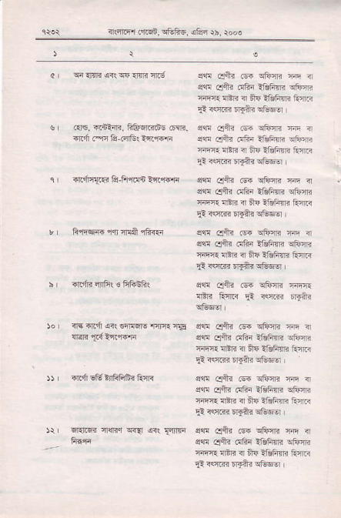
_{a} ^{qianE} Frwamcrd
s, .rrE, €t:rii- fitu6r.7ds .E!ri, d,"i.nrA @r&{i4ffi
_{e} ^{qdr{.R} E-Fi@n tfl"f@]i _{r tuqqrr ffr m.a} 'ii?{€
h ftft flFr € ftft3fi(
^{jor} {+ rrcd on 6rF5N- ncrq{ IIs )r I riid €ft infiFifri iiT<
_{)r fiin'6n iiqf<.r} ^{qq @r} {nnf
sqr eft _{F} ^{qtunri} r < eaE oS" .!fi! l|@fim atunr. _{Tr-n} ^{qtB} ? Bs Aiifim ft{F
sf cxtu @ EiFrm w . sd .1tu 6tii _{?GFiri} qturT rn{r _{nER} ^{q} Uq im{i ftnF
^{fiE} Oiti _{s{} ^{qFm} m ? ^{ce} _{eft?} ^{(rFi} _{:&fim} qfiEF nrm rEri i ET i1iF?ri ts4.i
^{qq} eltn @ ^{qft-*} _{T4q} q ^{qq} .$h trftr _{iAFm} qtuiri tir:r 4tri { ff{ ituF_ara A:nR
ssn cltu @ sililn Ten lili ^{arEi} _{5l} <,K F{?!
_{s@ .1lF .si} ^{qtum} m nr ec ldlr dfir _{iahm} qtum irT|l aBr3 a ffF i&Flri Q.lF _{!: rffi FE?i} q1t@o'
s{! cFt _{F} ^{qtur"} Tir a sln aq< olir _{?tuhmr} qem _{sliqr nft.} ^{q} il+ {gFffi Rm
sq! cji_r @ ^{qiim} ft ir _{s,'n} ^{qlh} 6tu _{ilAFsr.} qtoir3 ^{:rn?.} n'Err 4 Ar ildftlri FiF
a.ii@ .116B, srtuf{6, ^{oltri} $, rooo
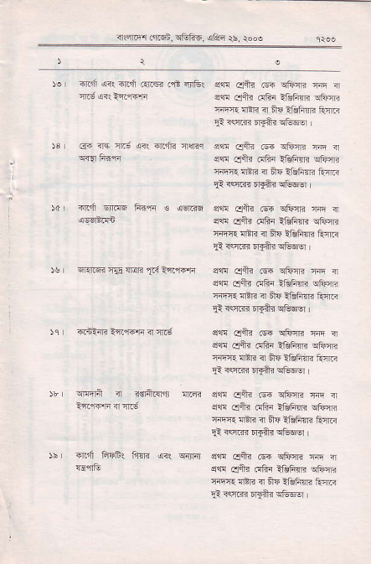
$ r arir @( -l.dl .nr6i .qt alEr $r _{G{} r]q fiis
)d ir.d snN F.{qr € sqrc _{5s r} ^{qr.rr* ie {I<li} ai ?ri,f+rr rr R-inr< -{'r-{i it {|.6
^{qrnrn} <r ndrftrrn {fm .n'i _{Frr& firli <R} q{rir
dll! _{cl6ir @} ^{qErr3} rii { Ee! enh irl?i _{lfqF"rn} qturir ^{'rirrr} 4'li ir ff4 !lklir'. torR
sretuFqfulriwa
slr! Elftr .i1i{ _{?1ihqrr} qFrR _{{n{q} ^{q'lr} n frF iffim ErlF
4a! €+r @ qtu{lr ^{'rfi} <r sqn dtu .!€r _{YdFni} qfinF rrE lBii ir fiE IRFR tor?
^{qd} _{cJfrn isrr} ^{q&m} ri! nr sq! otu tlFn _{!tuFm} qtum rni. 4rli ?r fiE {sfiR turR
s{q Otu _{.6{} ^{qFim} rfi n _{s$} ^{qftr} dhi _{Y&F$i} qfte 'rt'{I tER ir nE {&Fin ft{F
!@ €ir @ ^{qfiirn} rir a s€ ofti .!Fi _{i&Fm} ql4a'{ _{riEr} ^{qrnn} ir tT iifim Rnr{
srr _{4ltr} (qi ^{qFri} @ { _{s!'!} ^{qnr} dfir _{lr€Fnr!} qfim riF4: rER <r A{ IEF R ftnR
^{B}I
.c
I
!
, ^{g} ;! -i .i ^{E9} st : t: €* t ,Ei
a:.ZtE--
EE etr;!!-
2
.F.E ? EF i F+ ^ i
^{n'L} 4 ,- 8F-= t
E"s; :
3E€ ;
_{":E:} E
E! ; H.!,EIE ^{g;} E:qEE
€
E i :39!.F
_{E C.} gEE.EI
^{F.*:} ; EF5 -P
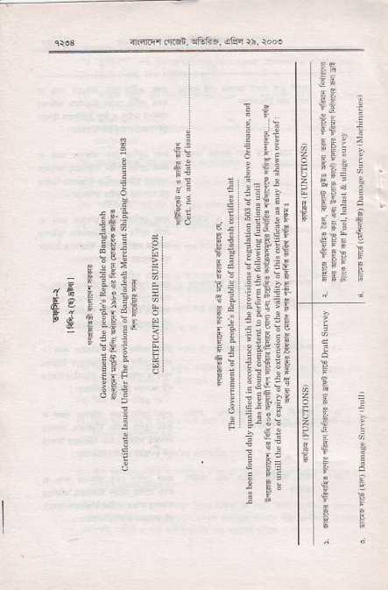
_{"c} EBEIr E
€ I Ei:5E E "E TgFEE E ' _{:E} q y
;r I E
_{i} ^{F-.!} 3
EE:
E F !IEE5€
b;:!r;Eii
^{p ! | 3:gtG q _-a, ES?:;} Fq:ii:if ^{E} "" E::!!
Et tsqEE E ! i!EiF E!:H5rls
!r!EEFF
EEE ,E !
.:
!: :.f e:
: i=
.,=
i !i
^{I}E
rE
irfirr _{onqi,} q6f1i-5. ^{qa,r} rh. t..e
FSFE
[*e5]i
^{E "c.:?€i} t 5 F: ! eF
;ni E * E ; r
6
_{Fi E F} ^{g E f E-} E:E ^{E;;E€;g} €iE EiEgE E:; _{;39 EAE:EEEF}
i ^{€E tti}i :t€ i !E€
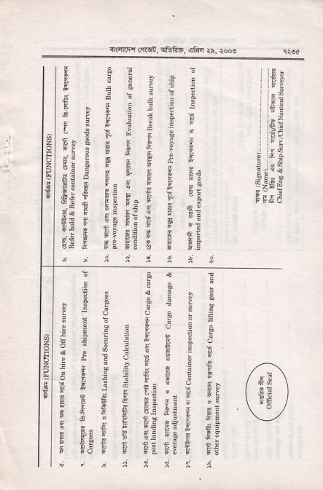
F
.cu ig'E ^{F 9i!} E€;JEEE$ _{if ;E;} g; F
:;c
2_{I}
;?E + F"oEJ
t
^{:-i5F-:e} stg;EHeE
_{E i : E tC i-} ^{p} cq ; $ F E €ifgp €E _{F F$E€ ;i;fl€ €g}
€
! t F.!
^{ir",5f.i'1} _{!1i5i. r:rF-} ^{jl$i} rh roo)
=
Fi
$f
_{Ei} !
^{qa} :
::::!t
::::E
tta
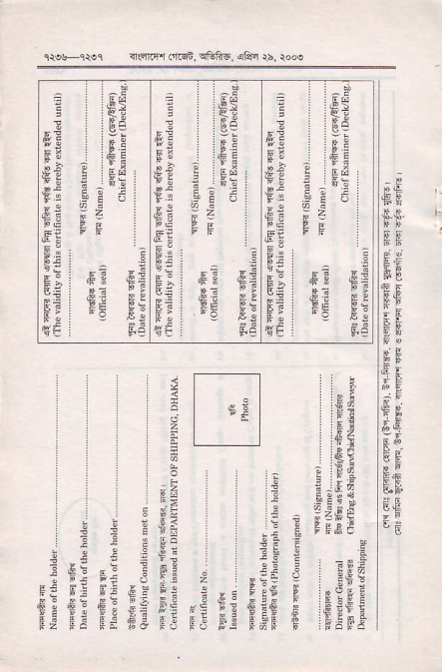
2
:?
I ^{Ei} : :e:
;.:t
F:
EE l ^{gE} l
e;
gF:
E:
:
SE
F5
,EJ
;t
| : ea
! n : ia
.E: EJ FJ _{E} 9 F:
:2
E5 !i!
Ei;d
: FF,Ee .E
f Ei:a
F: Fo FE if: e Fi
ii! r; = EE-

